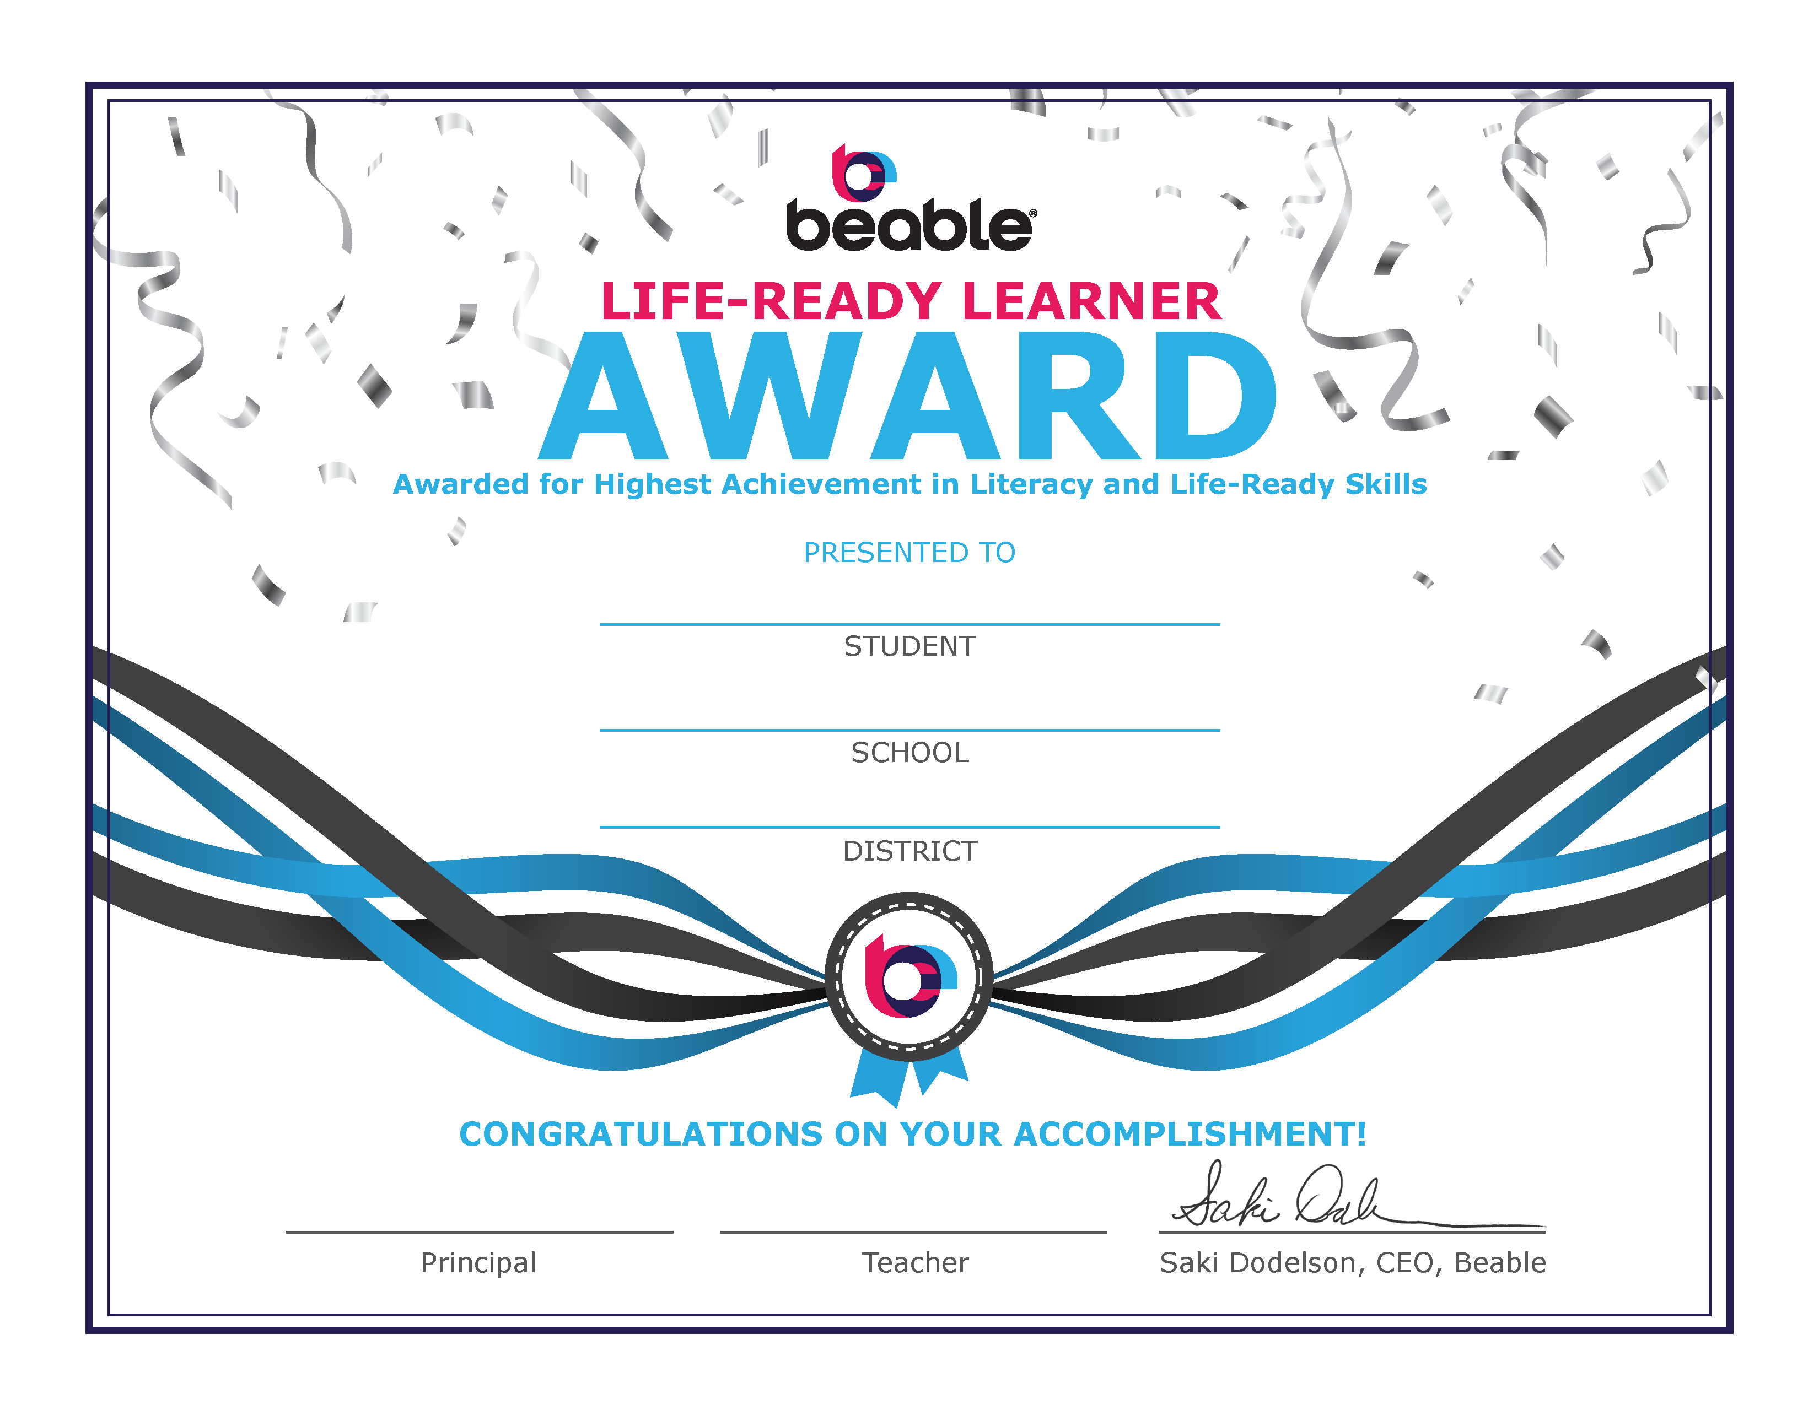

[Student Name]

[School]

[District]

[Principal]
[Teacher]

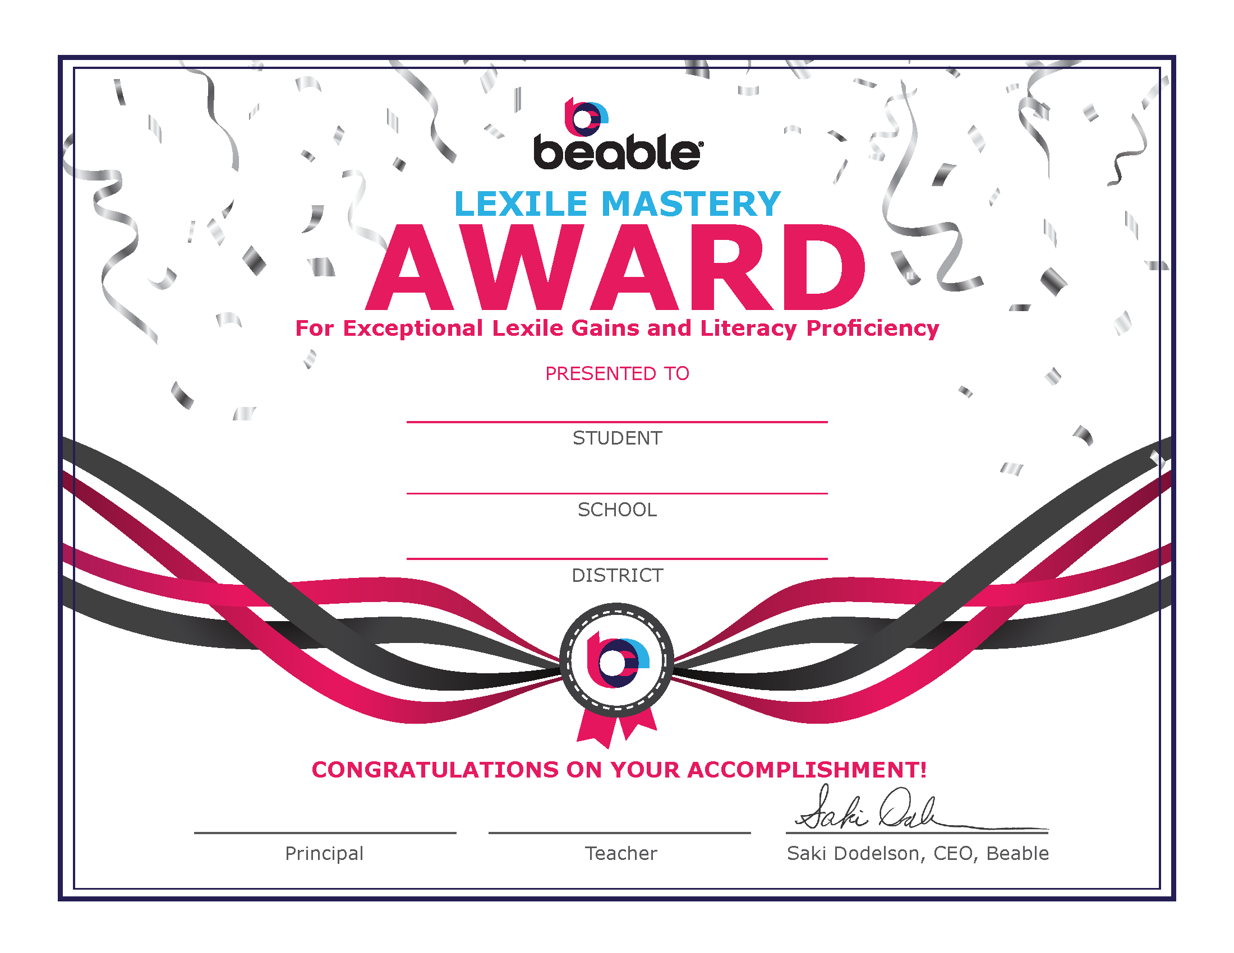

[Student Name]
[School]
[District]
[Principal]
[Teacher]

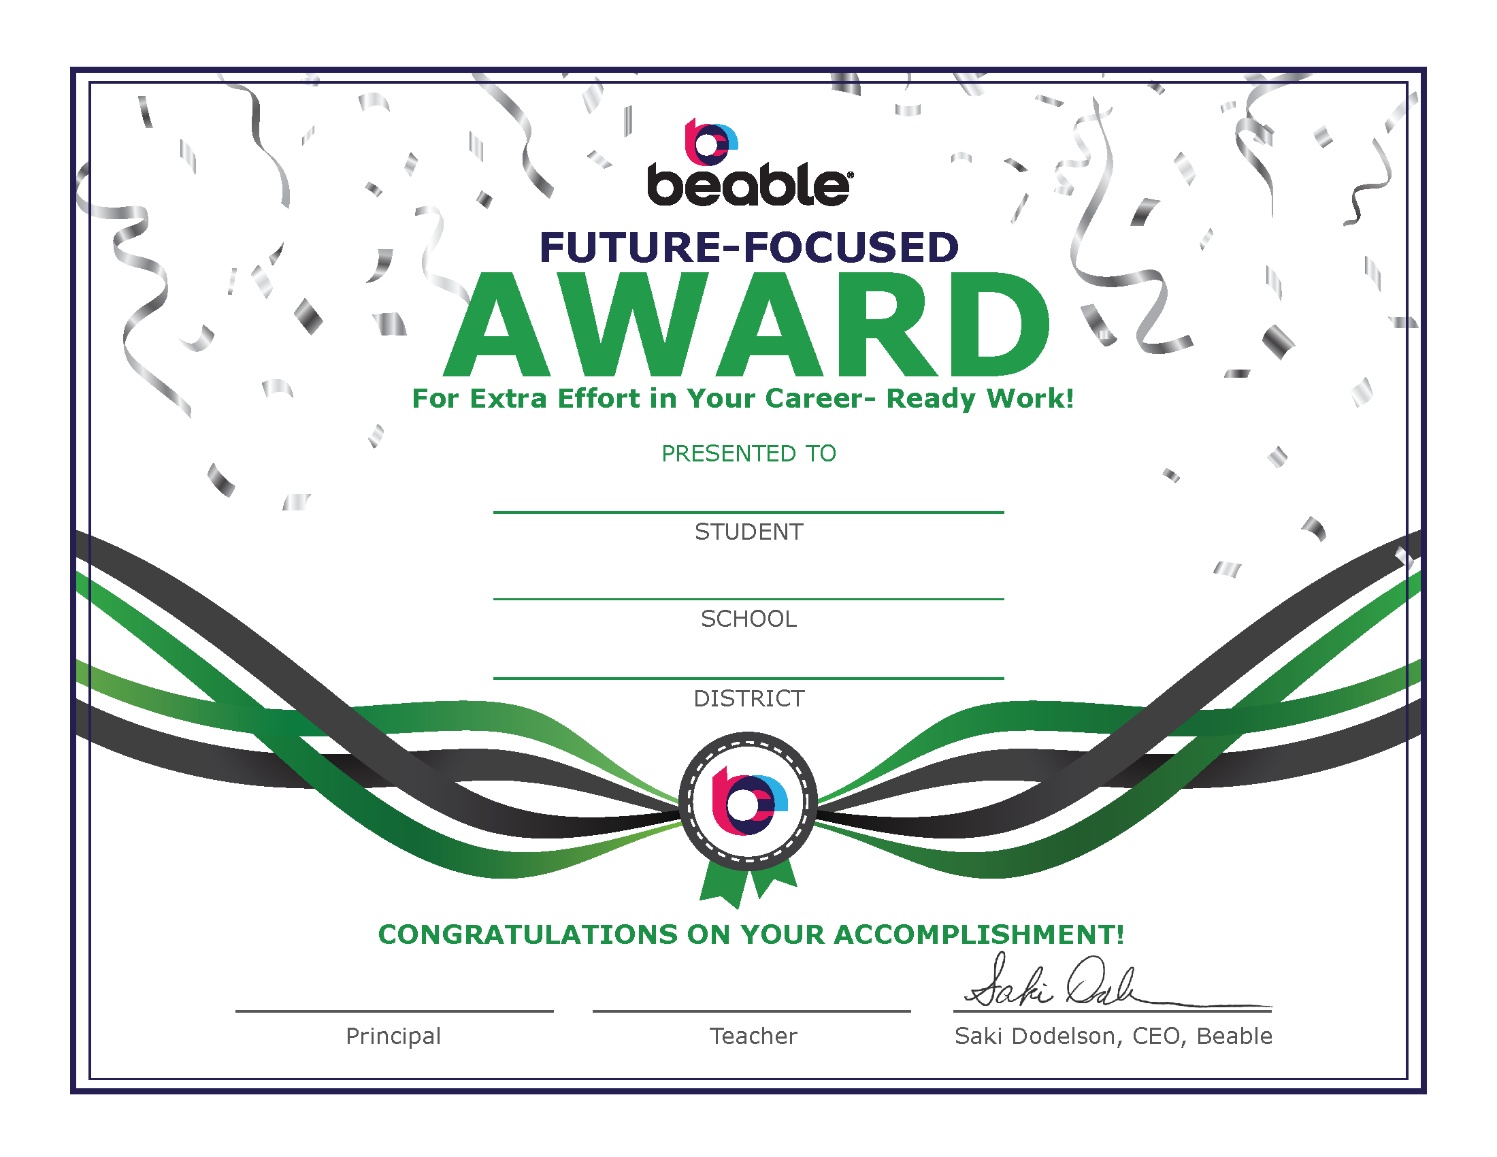

[Student Name]
[School]
[District]
[Principal]
[Teacher]


[Student Name]
[School]
[District]
[Principal]
[Teacher]

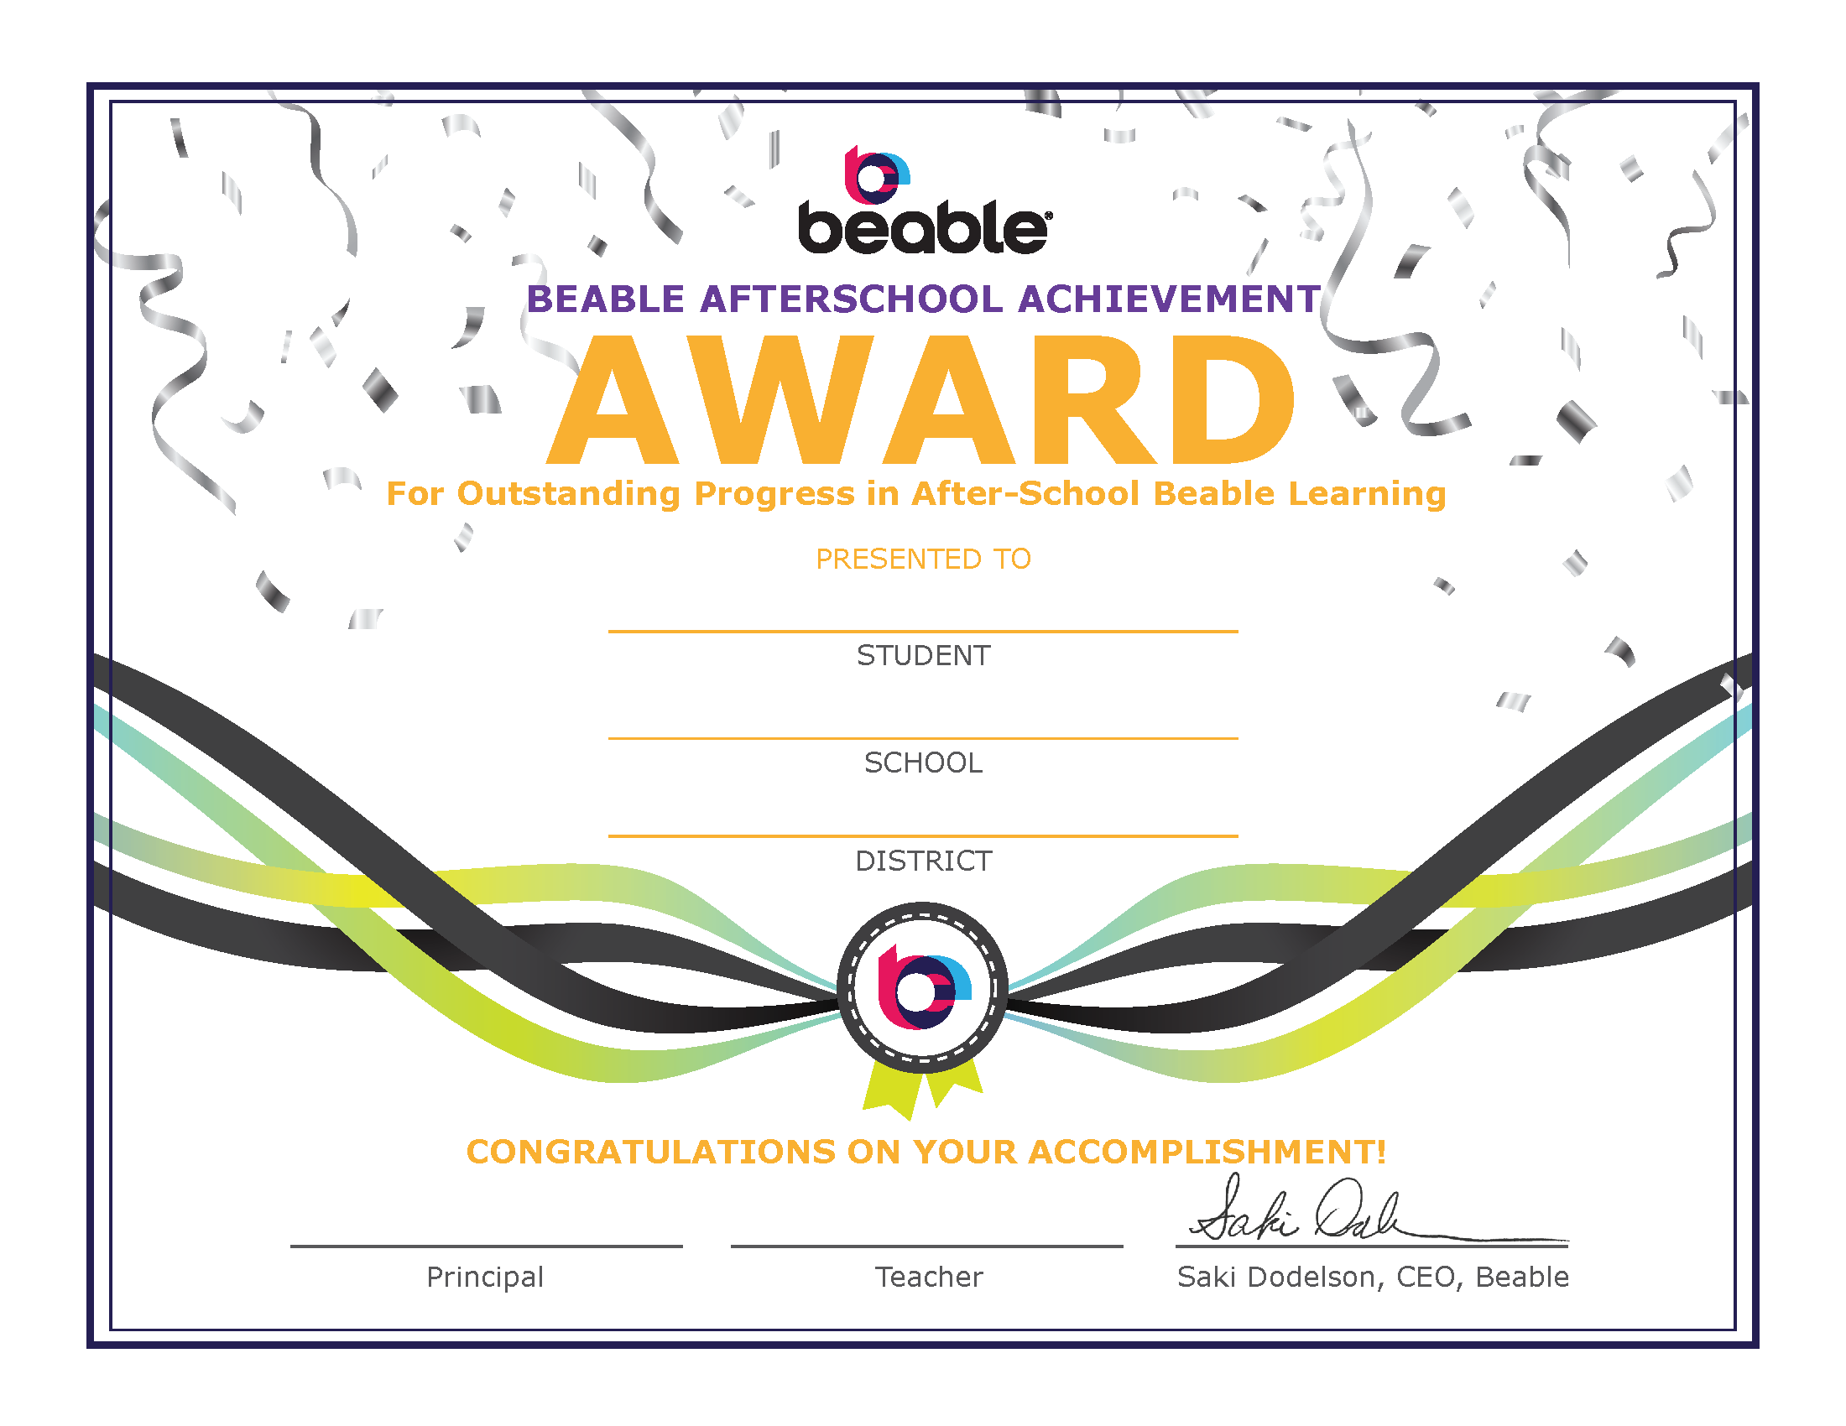
[Student Name]
[School]
[District]
[Principal]
[Teacher]

